Ruprecht-Karls University Heidelberg

Faculty of Chemistry and Earth Sciences

Institute of Geography

Winter Term 2018/2019

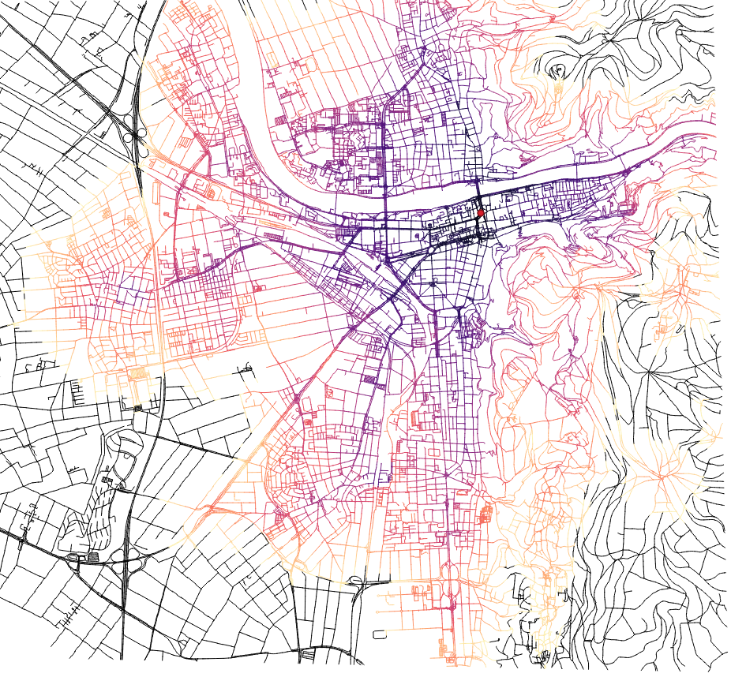

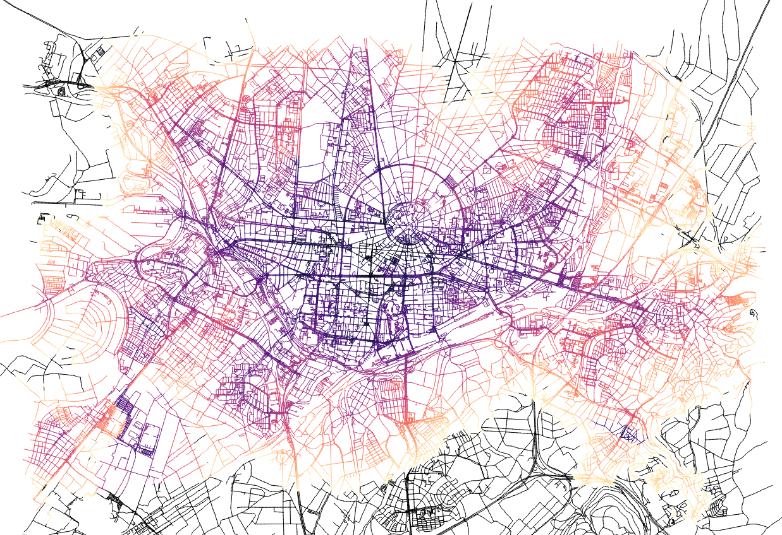

**Connectivity analysis for cities including public transportation**

Czizewski Philippé Stier Jochen

MtkNr. : 3385951 MtkNr. : 3381546

czizewski@stud.uni-heidelberg.de j.stier@stud.uni-heidelberg.de

lecture: GIS analyses with free and open source software

lecturers: Julian Bruns, Christina Ludwig

15.04.2019

Table of contents

1. Introduction 4

2. Study area and data sets 5

3. Analysis workflow 6

I. Importing and preparing data 7

II. Network 1 9

III. Extracting categories from Network 1 11

IV. Network 2 12

V. Calculating the shortest time 13

VI. Exporting final layers 16

4. Visualized analysis results 17

5. Solved issues 18

6. Evaluation 19

# List of dependencies

GRASS 7.4.0

QGIS 3.4.1

Git 2.19.1

Overpass Turbo 13.09

# 1. Introduction

Public transportation and low departure times are crucial topics for the development process of modern cities as populated areas tend to grow even larger in the future, while many local inhabitants are still dependent on public infrastructure with short transportation times to reach their workplace and public institutions on regular basis. Besides most urban areas with a high car dependency face challenges such as increased travel periods due to congestion as well as noise and air pollution. With the ban of diesel vehicles in large German cities and the rising awareness in climate protection, the importance of public transportation in major cities increases even more.

Therefore our analysis focuses on the accessibility of civic centers in selected cities including the local public transportation. The script analyzes the infrastructure network in a defined study area on the example of Heidelberg and Karlsruhe and gives information about how fast the user can reach the civic center from the remaining city area by public transportation and foot.

In order to introduce our analysis in this paper we will first present our selected study area as well as the data sets and data sources used to perform the script.

Following we will walk through the script in detail and describe the performed steps and their effect as part of the workflow.

After displaying the solved problems which occurred during the processing of the script, we will end the paper with an evaluation which will show possible improvements and the limitations of our analysis.

# 2. Study area and data sets

As primary study area we chose Heidelberg and Karlsruhe, on which we also tested the script of our analysis. We decided to focus on these two cities because they are mapped on OpenStreetMap with great detail and accuracy. Furthermore both cities possess a well developed public transportation network with various bus and tram lines. The size of the cities were ideal for our analysis since they lack on substantial subway or train lines, which are currently not included in the script.

We obtained the necessary OpenStreetMap data sets for our analysis using the Overpass turbo API. By generating multiple queries with different tags, we gathered data about the city’s respective street network as well as data sets for public transportation lines and stops   
(e.g. fig. 1).

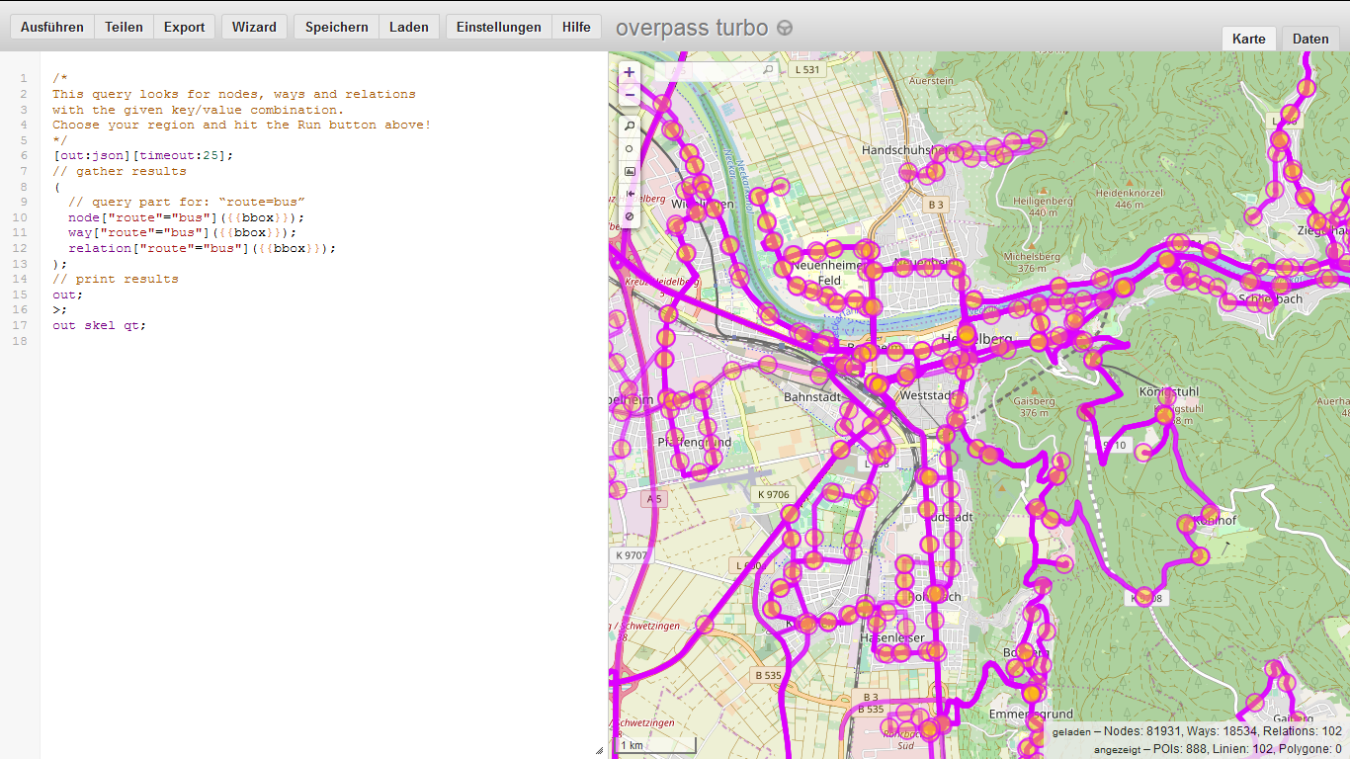

Figure 1: Overpass turbo query for buses in Heidelberg

Since the workflow requires a certain civic center to perform, we chose the Bismarckplatz for Heidelberg and the Europaplatz for Karlsruhe as central point for their respective city. These town squares are particularly well suited for the analysis because they are connected to the majority of bus and tram routes inside the study areas, as well as being highly frequented on a daily basis. We digitized the two points in QGIS and transferred them to GRASS GIS as Shapefiles.

To keep account of the unequal transportation speed of the three primary transportation methods (bus, tram and by foot) included in the script, we manually added the average speed times in an own column. For a mixed route by bus and tram we simply calculated the average speed for both transportation methods.

# 3. Analysis workflow

Now we will present the workflow of our analysis by explaining the code of the script used to perform the analysis:

Before the data preparation and import can be started, the necessary GRASS tools and library for importing data into python had to be prepared. To prevent data corruption by old vector data from previous iterations, the data base elements from the user’s current mapset get removed by the ‘g.remove’ command (fig. 2).

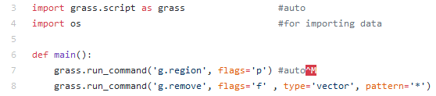

Figure 2: Analysis preparation

## I. Importing and preparing data

At first the initial data had to be prepared and imported into Python to perform the analysis. For that reason three different base paths got defined, which were later used to load and store data. The cache is necessary for the assignment of unique IDs in a later step, the data stored here is of no further interest.

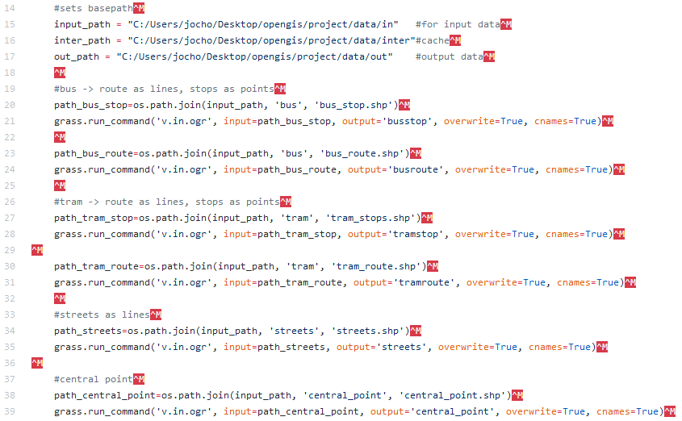Bus route data sets are added as lines and bus stops as points, which is also done with tram routes and stops. The street network was integrated as lines as well, while the civic centers got assigned as points (fig. 3).

Figure 3: Base paths & data import

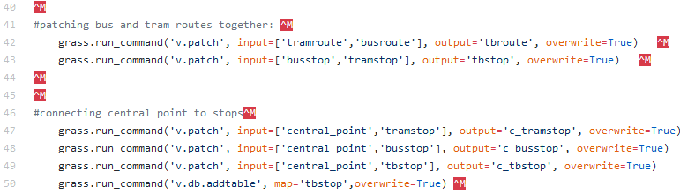In order to enable a switch between tram and bus routes with a mixed route of both transportation methods, both public transportation lines were patched together. This also expands the public transportation net by areas, buses and trams can’t reach themselves in the same time compared with a mixed route. The same was done with the civic centers and stops, which is a prerequisite for the ‘v.net.iso’ command used later in the analysis (fig. 4).

Figure 4: combining lines and points

‘v.net.iso’ uses a range of points as centers from which the distance across the network is measured. The civic centers are added to the stops as preparation for ‘v-iso’. That way ‘v-iso’ can connect the transportation lines to the stops and the civic center at the same time.

After patching the two layers together, they have to get exported and imported again, to assign an individual ID to each point (fig. 5). Since the public transportation stop layers are patched from two different layers, the first ID of both layers would overlap which could cause an error with the ‘v.net.iso’ command.

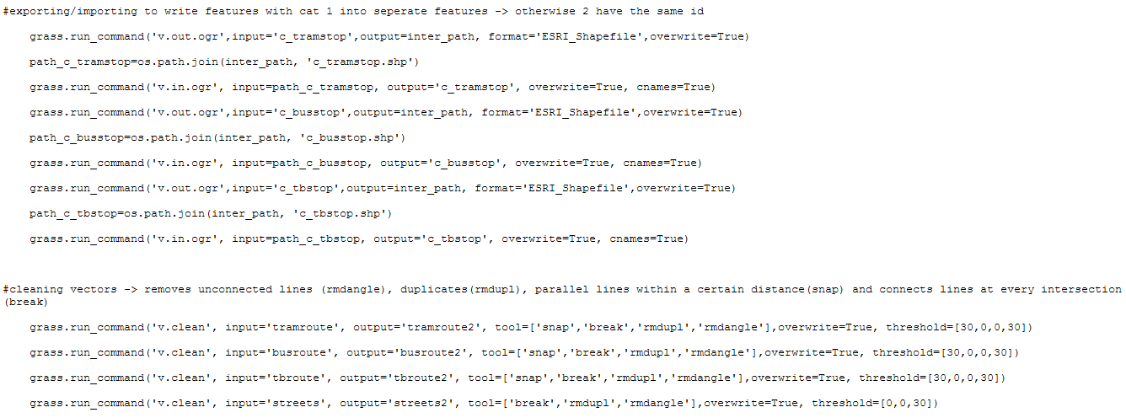

Figure 5: Assigning individual IDs & cleaning vectors

Additionally the street and public transportation layers get cleaned by removing unconnected paths, duplicates and parallel lines (snap) as well as connecting lines at every intersection. Connecting the separate lines by using the ‘break’ tool is crucial for the analysis, otherwise only lines that go through the central point would be considered drivable by our script. This step wouldn’t be necessary if we had another solution to take account for the change in lines.

## II. Network 1

The following steps gets executed 3 times, to build the network for traveling by tram, bus or bus and tram. The data is now prepared for the construction of our first networks. The first network is used to calculate the time necessary to reach each stop from the civic center.

The command ‘v.net’ creates a network layer using the points and lines of the different public transportation layers for bus and tram despite the difference in the data’s dimension (fig. 6). The operator ‘connect’ links points to the closest line, in our case the stops and the central point to the bus or tram lines.



Figure 6: Connecting central point to lines

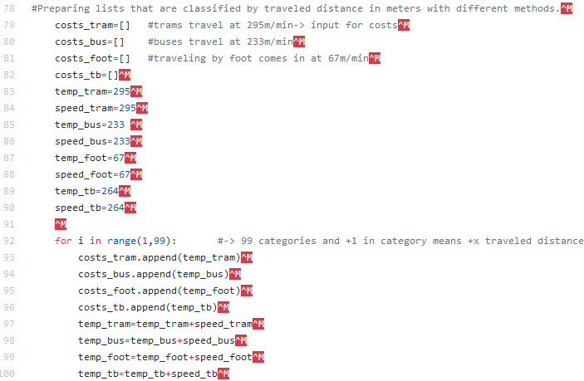Following that we further prepare our first network analysis. Our command ‘v.net.iso’ requires ‘costs’ as an input which is measured in meters. If you would input the values 3 and 5 the command would simply split the net into three categories: lines which are under three meters away from the civic center (cat 1), lines between three and five meters (cat 2) as well as lines that are even further away (cat 3).

Figure 7: Preparing costs for 'v.net.iso' with average speed times

The code above creates a list which classifies the lines according to the average speed of the public transportation methods (fig. 7). For example: A tram in Heidelberg has an average speed of 295 meters per minute. It takes up to one minute for a tram to reach a stop which is 0 to 295 meters away, to travel another 295m it takes an additional minute. If we input a list which contains x values calculated with the function “x=295*X” meters (**295**, **590**(*295+295*), **885**(*295+295+295*)….) as costs, it splits our net into x different categories (cat 1,2,3…) who match the time necessary to cross the respective distance. If a point on a line has the forth category, it would take four minutes to reach that point from the civic center – for example.

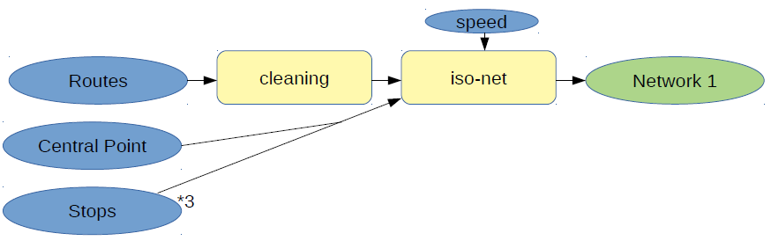

Figure 8: Workflow Network 1

Figure 8 is a short summary of what has happened so far. Each steps happens 3 times, so in the end we have 3 different networks. The command ‘v.net.iso’ splits the net into bands between cost isolines (fig.9). ‘center_cat 1’ is our initial civic center, the costs were calculated in the previous step.

Figure 9: First network analysis 'v.net.iso'

## III. Extracting categories from Network 1

Since ‘v.net.iso’ doesn’t automatically create a table filled with the created category numbers, we have to perform this step manually. The table is created as a preparation for ‘v.distance’ (fig.10).

After this we add columns to the stop layers, which will be filled with the values (cat 1 - X) of the closest line from network 1. This happens with the ‘v.distance’ command, which simply searches for the nearest feature in another layer for each point in the input layer. The tool also has the option to copy one of the attributes of the nearest feature to the input feature. Since the nearest feature is always the line that was connected to the stops with ‘v.net’ (fig. 6) the tool can be used to assign the time that is needed to get to the stop from the civic center to the stop layers.

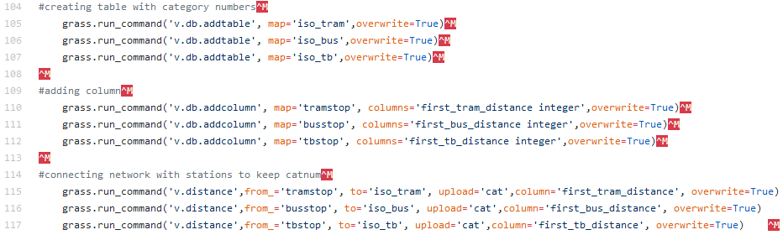

Figure 10: Add Category number table

## IV. Network 2

The second network is used to calculate the necessary time to travel from any point in the study area to the closest public transportation station by foot.

Again the command ‘v.net’ is used to create a network, this time with the public transportation stops and street network (fig.11).

Figure 11: Connecting tram stops to streets, Network 2



Similar to before a list is created which is fed to ‘v.net.iso’ as ‘center_cats’ (fig 12). The list contains the numbers 1 to 999 – since all points in the second network are stops, every point in the network is considered as center.

Like this the resulting network category, which is calculated by the second network analysis in the following step, now correctly depicts the necessary time from any position in the city towards the closest bus or tram stop.

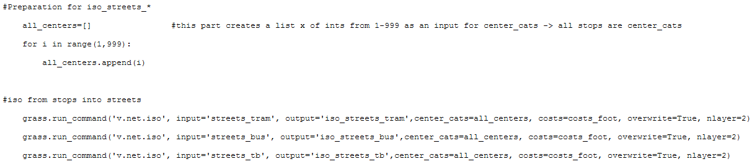

Figure 12: Preparation and second network analysis

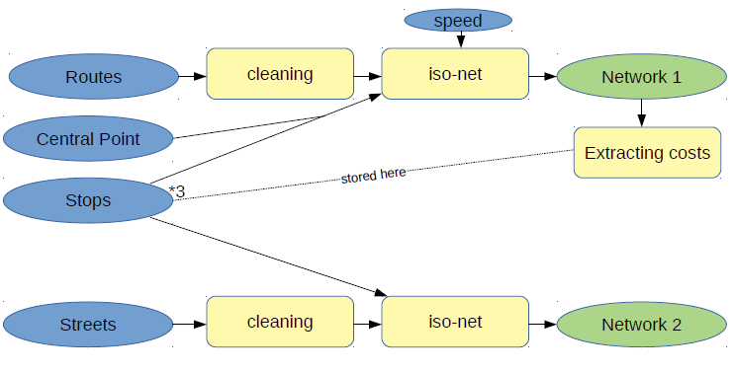

Figure 13: Workflow Network 2

Another short summary of what has happened so far can be seen in figure 13. The lower part shows the creation of network 2.

## V. Calculating the shortest time

After creation the second network with isolines gets exported and imported again, to convert the network layer into a vector layer, and to split the network into features with individual IDs (fig. 14). The features get split at each transition between category (cat) numbers. Each feature still has the cat value of the network but it now also has its own unique ID.

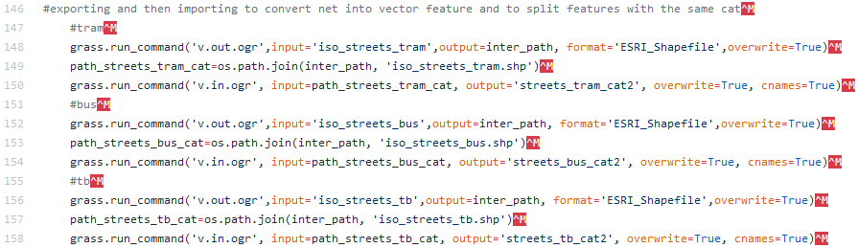

Figure 14: Converting net layers

A new column is created in the attribute table of the re-imported network. Here we want to store the information, how long it takes to get from nearest stop to the civic center. Again ‘v.distance’ is used and the values which were stored in the stop layers get transferred to the network 2 layers. Now each feature contains the information how long it takes to get to the nearest stop and how long it takes to get from that stop to the civic center.

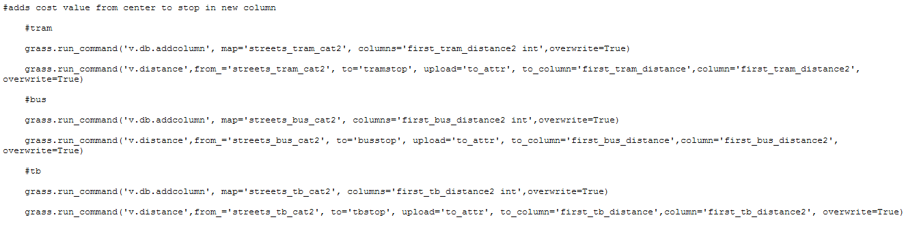

Figure 15: New column for time needed between streets and stops

A final column is added, filled with the time needed to reach the closest stop plus the necessary time to travel from that stop to the center (fig.16). For a mixed net containing trams and buses (tb), ‘+5’ is added to simulate at least one switch in lines between bus and tram lines. Obviously the 5 minutes change time added this way is a rough estimation since the average waiting time can vary for different cities, weekdays and times of day. For our study area Heidelberg and Karlsruhe most buses and trams arrive on a 10 minute rhythm between Monday and Friday, which would result in an average waiting time around 5 minutes.

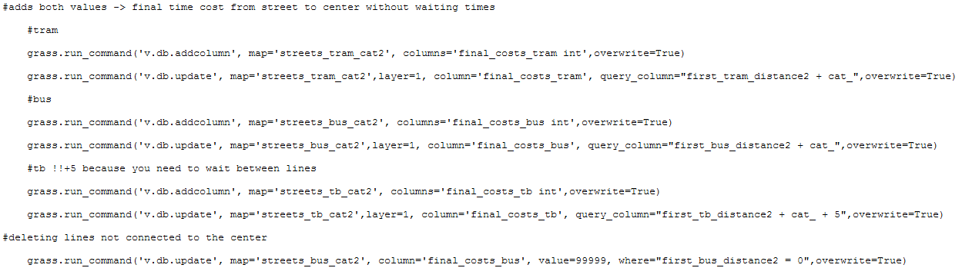

Figure 16: Total travel period & change of lines

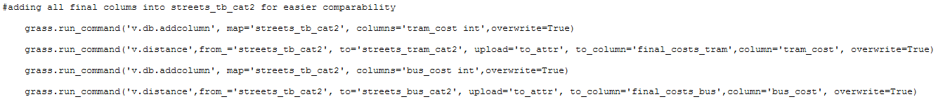In preparation for the last step of our analysis we add the final cost values for the bus and tram nets into the mixed net ‘streets_tb_cat2’ for easier comparability (fig.17).

Figure 17: Adding values into layer 'streets_tb_cat2'

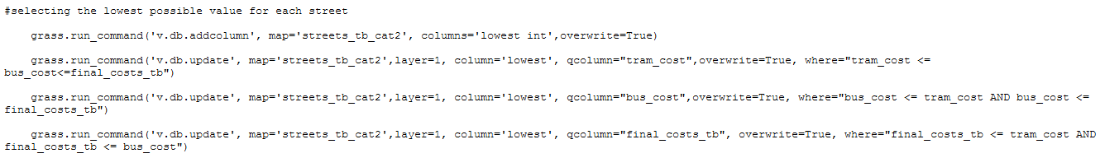The final value for each section on the streets is then calculated by comparing the 3 different cost values and choosing the lowest one. The resulting values are a rough estimation of how much time it takes to reach the civic center from any given point in the city (fig.18)

Figure 18: Calculating lowest value for each section

## VI. Exporting final layers

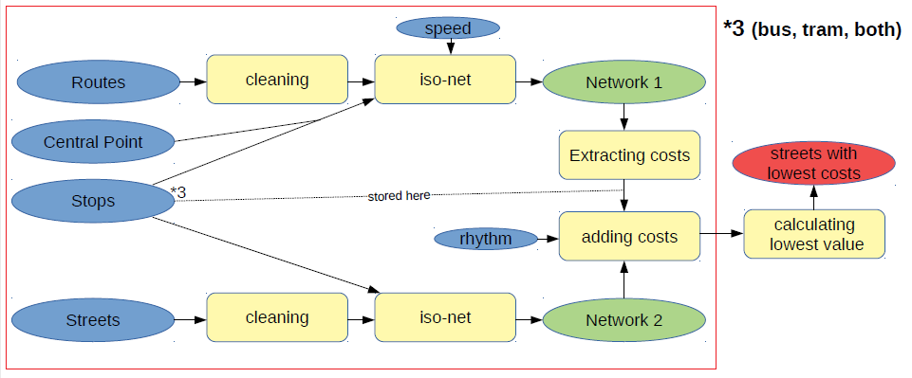

Figure 19: Complete workflow of the analysis

Figure 19 shows an overview of the whole analysis. In the end the final layers get exported in the shapefile format (fig.20). This way the obtained can be used outside of GRASS GIS. For example, they could be used to visualize the results of the analysis in QGIS.



Figure 20: Export of obtained results

# 4. Visualized analysis results

Figure 21: Visualized results of Heidelberg

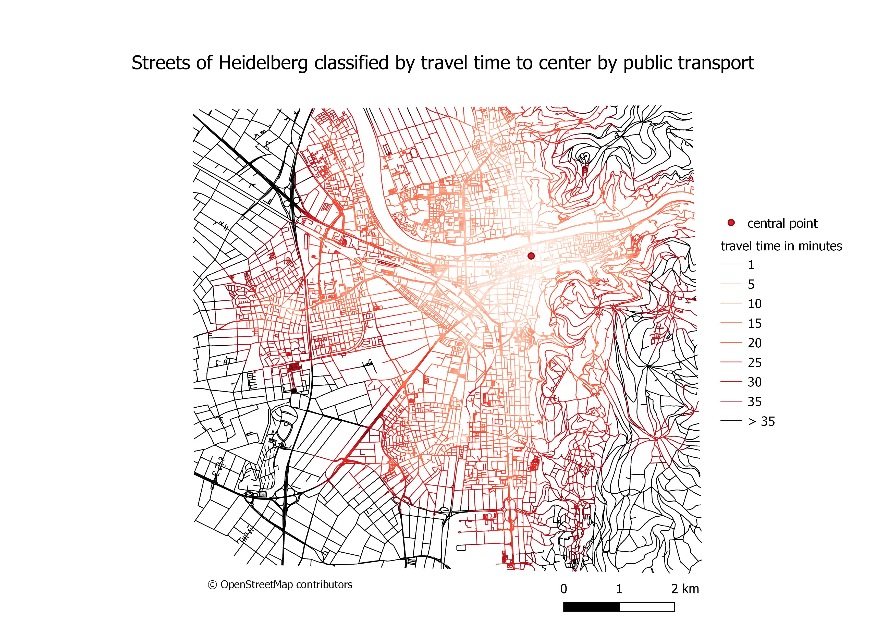

Figure 21 shows a visualization of the resulting data for the study area of Heidelberg. A lighter red color indicates a very short travel time to the center, the darker the shade gets the longer it takes to reach the town square. If it takes more than 35 minutes to reach the civic center the streets is displayed black. You can see that most quarters have a good connection to the center. Only the district Emmertsgrund is mostly dark red or black. The results are not surprising, since Heidelberg has a good public transportation infrastructure and is relatively small.

Figure 22 shows Karlsruhe, the second study area. Only visualizing the final value in shades of red did not provide a good overview, that’s why more colors were used. Black is used in the center to indicate a low value, and for values that are above 45 minutes. In the picture you can see, that most districts are connected to the center, only one in the south seems to be missing. It is possible, that this district is not connected to the public transportation net at all, but it is also possible that the line is just not mapped in OpenStreetMap.

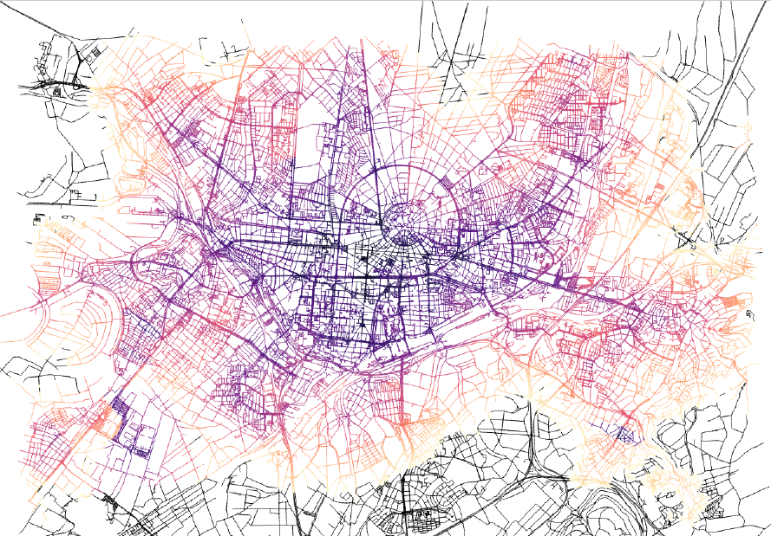

Figure 22: Visualized results of Karlsruhe

# 5. Solved issues

During the processing of our analysis we encountered various issues, which we already solved on our own:

Before we could import shapefiles into GRASS GIS it was necessary to change a few attribute names in tables, which are reserved key words in SQL – in this analysis ‘to’ and ‘from’.

The command ‘grass.run_command('v.distance',from_='tramstop', to='iso_tram', upload='cat', column='first_tram_distance', overwrite=True)’ caused an error since it uses a reserved keyword from SQL (‘from’). If you use an underscore after the keyword, the tool will work, e.g. ‘from_’.

In GRASS networks don’t work as individual features, for which reason the net had to be split. By exporting the net as shapefile and re-importing it again we fixed this problem. The same solution was used to split multiple features which shared the same ID.

# 6. Evaluation

As a conclusion we will discuss the results of our analysis, reflecting on possible improvements and critique towards the script:

The script was tested on the study area of Heidelberg and Karlsruhe and worked accordingly, delivering pleasing results. For example the values given for Heidelberg in the areas of Eppelheim and Rohrbach were quite accurate compared to the actual travel times. However the script took between 4 to 15 minutes to process the original data. This might indicate that the algorithms used weren’t the most efficient.

The implementation for switching lanes isn’t ideal. The static value added (+5 min) doesn’t reflect the reality adequately, since public transportation schedules can vary heavily between different cities, week days or times of day. In rural areas an average of 5 minutes for a change of lines would be unrealistic. Additional the average speed of bus and trams may vary between different cities or countries too, which would require a manual change of the average speed times included in the analysis script. Instead of average speed times it would be possible to include actual time tables for the respective stops, which would lead to more accurate results especially in the area close to the civic center.

With a growing size of the analyzed cities and an increasingly intersected public transportation network, the solution of the script gets increasingly worse. Since the algorithm always takes the shortest path along the public transportation lines, the chance of selecting a path which isn’t actually used as public transportation line is increased. In very large cities the definition of one civic center might be difficult too, since many of those cities possess more than one major town square which would be suitable as civic center for the script. On top of that alternative transportation methods such as bike or train might have an increased relevance in bigger cities, which would promote an expansion of the script.